## 3. Project Plan

### Understanding the Project

➢ **Objective:** Develop a robust and scalable billing system for retail environments. 

The system will manage customer registrations, item inventories, generate PDF bills, and ensure secure transactions.

➢ **Stakeholders:** Retail store owners, cashiers, customers, system administrators, and the development team. 

### ➢ Project Goals: 

* Streamline the billing process.
* Enhance inventory and transaction management.
* Provide secure, real-time updates on customer data and inventory.
* Ensure scalable and multi-user access with robust authentication.

➢ **Scope:** Includes customer management, item management, real-time inventory tracking, billing, report generation, and secure data handling with encryption. 

### Tools Used for this Project

* Java Swing: For front-end GUI.
* SQL (MySQL): Backend for managing customer and inventory data.
* PDF Libraries: For generating bills.
* Agile Tools: JIRA or Trello for sprint planning and task tracking. • Git: Version control system.

### ➢ Develop: 

* Custom modules for customer, item, billing, and reporting functionalities.
* Real-time inventory updates.
* Secure authentication and PDF bill generation.

### ➢ Reuse: 

* Pre-existing libraries for PDF generation.
* Standard authentication libraries.

➢ **Buy**: 

* Optional third-party tools for analytics if custom reporting is not sufficient.

**Work Breakdown Structure**

### ➢ Team Structure: 

* Product Owner: Responsible for requirement prioritization and stakeholder communication.
* Scrum Master/Project Manager: Facilitates the Agile process, tracks progress.

### ➢ Development Team: 

* Front-end developer (Java Swing).
* Back-end developer (SQL, PDF generation).
* Database Administrator (DBA).
* Testers for unit, integration, and system testing.
* Business Analyst: Collects and refines requirements.

### ➢ Responsibilities: 

* Admin: Access to all modules (customer, inventory, billing, reports).
* Staff: Access to customer registration, billing, and stock check.
* Developers: Responsible for system development and integration.

### ➢ Effort Estimation: 

* Use Agile story points for task effort estimation.
* 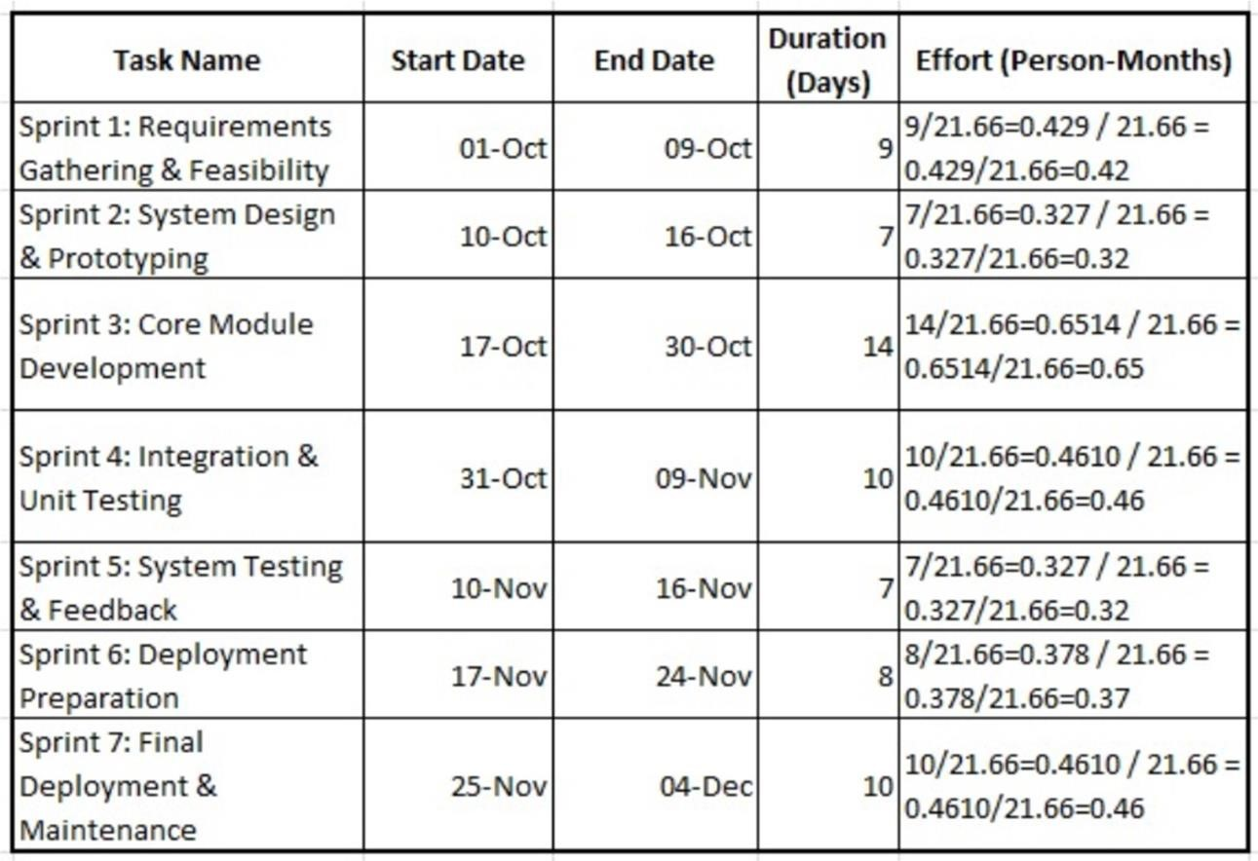Assign resources based on expertise and task complexity.

### Gantt Chart

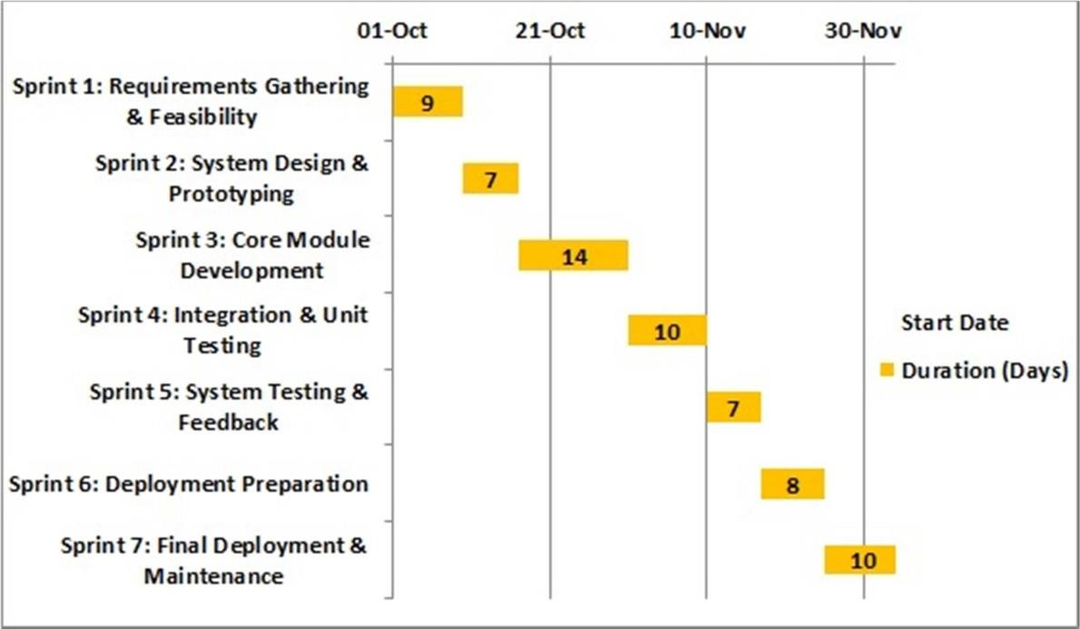

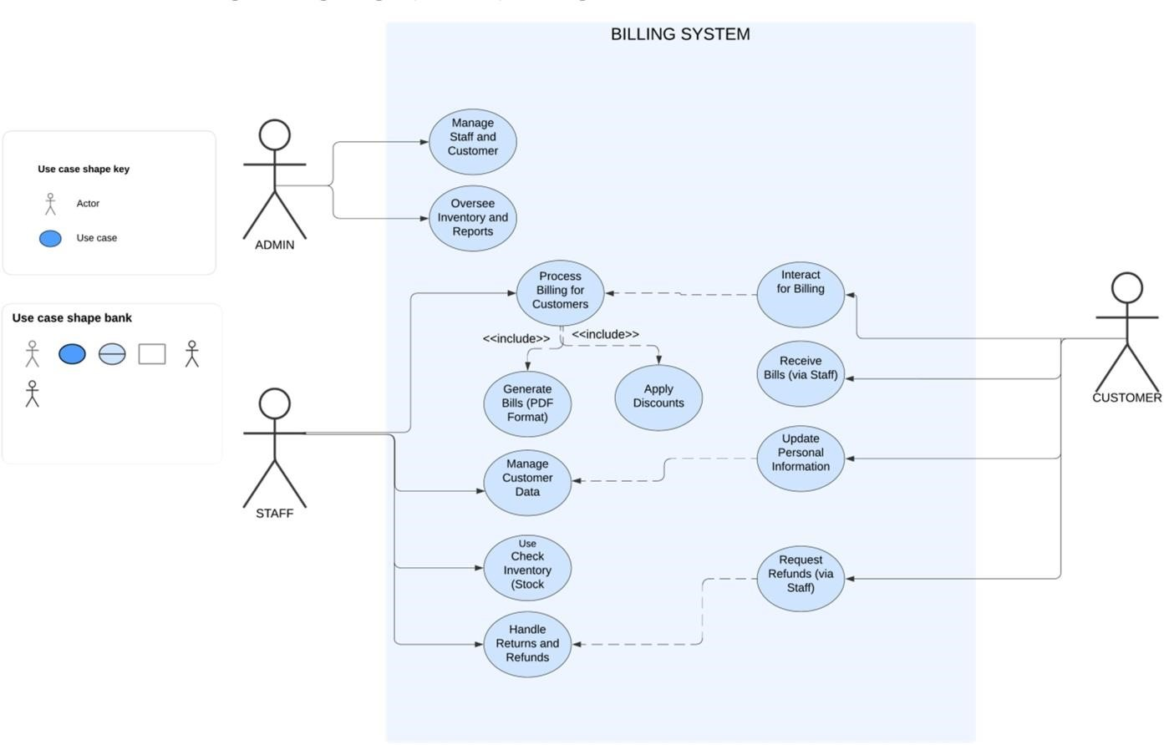**Data Flow Diagram Logic**

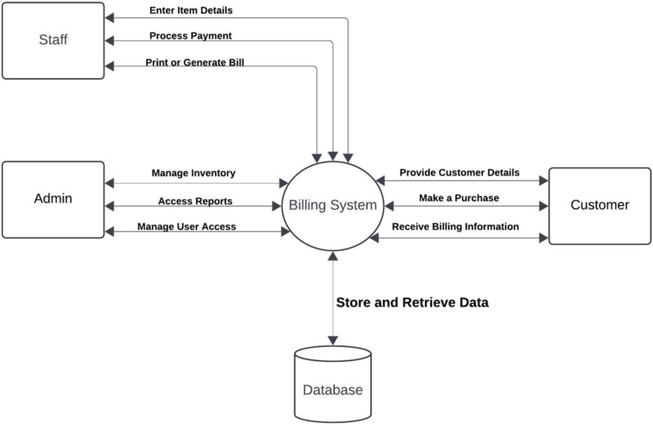

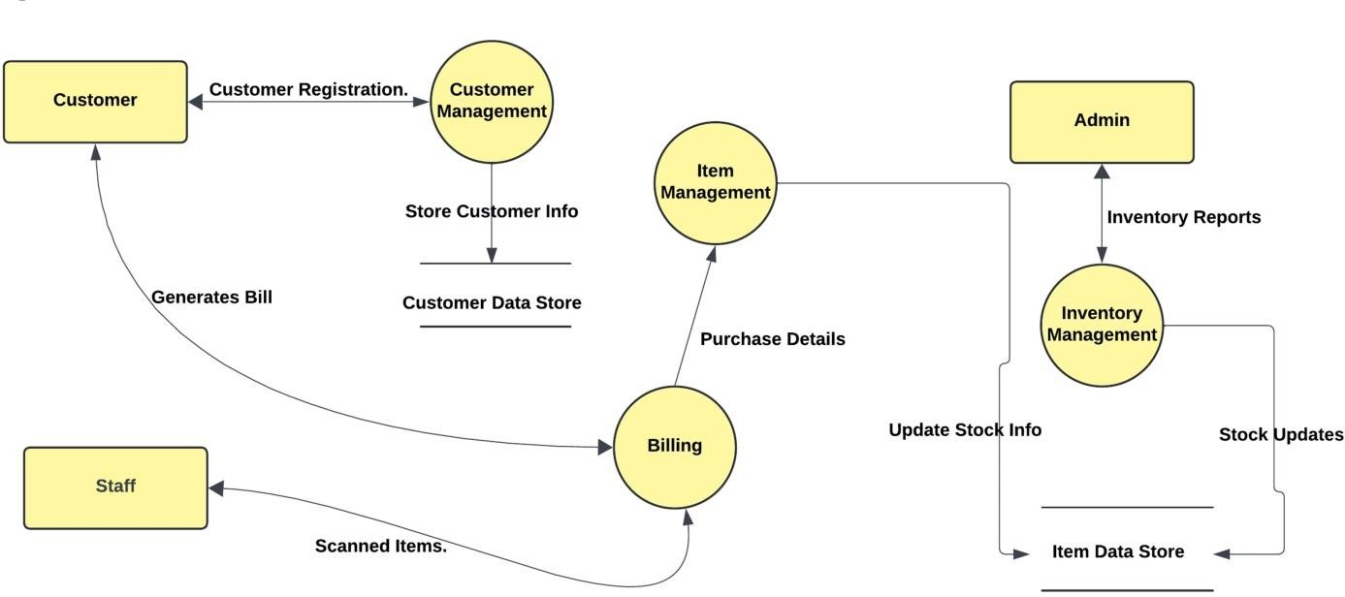

### Logic 2

